# Decision Making in C

Decision making statements in programming languages decides the direction of flow of program execution. Decision making statements available in C++ are:

* [if statement](https://www.geeksforgeeks.org/decision-making-c-c-else-nested-else/#if)
* [if..else statements](https://www.geeksforgeeks.org/decision-making-c-c-else-nested-else/#if-else)
* [nested if statements](https://www.geeksforgeeks.org/decision-making-c-c-else-nested-else/#nested-if)
* [if-else-if ladder](https://www.geeksforgeeks.org/decision-making-c-c-else-nested-else/#if-else-if)
* [switch statements](https://www.geeksforgeeks.org/switch-statement-cc/)

**if statement**

if statement is the most simple decision making statement. It is used to decide whether a certain statement or block of statements will be executed or not i.e if a certain condition is true then a block of statement is executed otherwise not.  
**Syntax**:

if(condition)

{

// Statements to execute if

// condition is true

}

**Flowchart**:  
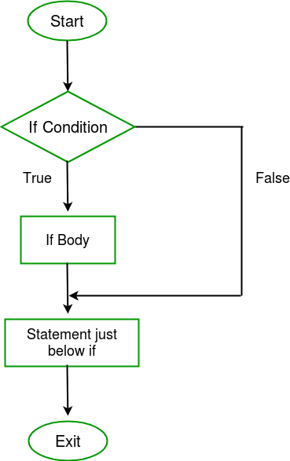

**if- else**

The if statement alone tells us that if a condition is true it will execute a block of statements and if the condition is false it won’t. But what if we want to do something else if the condition is false. Here comes the else statement. We can use the else statement with if statement to execute a block of code when the condition is false.

**Syntax**:

if (condition)

{

// Executes this block if

// condition is true

}

else

{

// Executes this block if

// condition is false

}

**Flowchart**:  
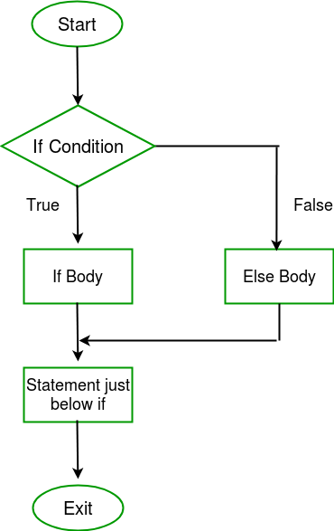

**Nested-if**

A nested if is an if statement that is the target of another if statement. Nested if statements means an if statement inside another if statement. Yes, C++ allows us to nest if statements within if statements. i.e, we can place an if statement inside another if statement.

**Syntax**:

if (condition1)

{

// Executes when condition1 is true

if (condition2)

{

// Executes when condition2 is true

}

}

**Flowchart**:  
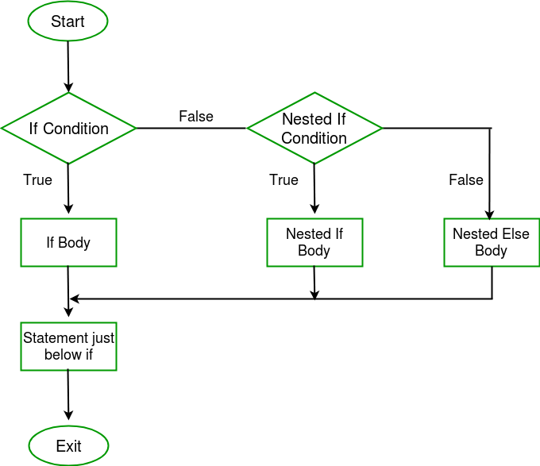

**if-else-if ladder**

Here, a user can decide among multiple options. The if statements are executed from the top down. As soon as one of the conditions controlling the if is true, the statement associated with that if is executed, and the rest of the ladder is bypassed. If none of the conditions is true, then the final else statement will be executed.  
**Syntax**:

if (condition)

statement;

else if (condition)

statement;

.

.

else

statement;

**Flowchart**:

